***Events in javascript : (Events Link)***

A good website is a responsive website. The user does something—clicks a button, moves the mouse, presses a key—and something happens.

* The user types a number in the Ounces field on a form. When she clicks in the Grams field, the equivalent in grams displays.
* few examples: The user clicks a button saying "Our Guarantee" and an alert displays spelling out the guarantee.

**Lets first see practical example of in_line event handling :**

Executing html script inside of it writing javascript code and it displays as a link at the browser which performs an action whatever a coder placed as javascript code.

you place a # inside the quotation marks. This tells the browser to reload the current page.

onClick= says, "When the button is clicked, execute the following JavaScript."

The message inside the parens is surrounded by single quotes, not the double quotes we've been using for an alert string.

Syntax:

<a href=………………………………….>Click</a>

Example :

<a href="#" onClick="alert('Hi');">Click</a>

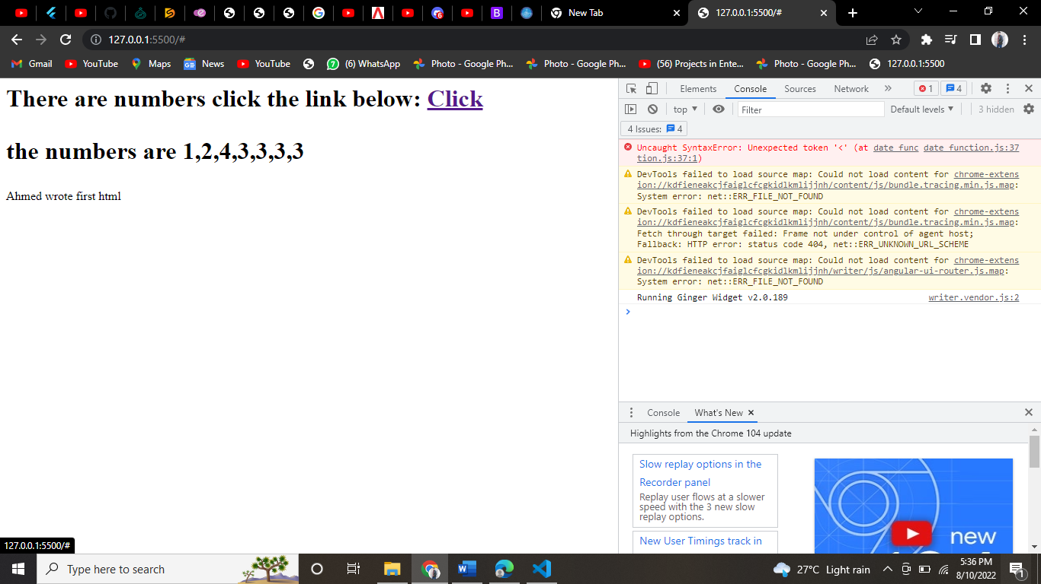

To call a function to be executed when we click the link we do following steps :

 //step 01 making a function:

<script>

            function add(a,b) {

            var sum=a+b;

            alert(sum);

            }

        </script>

//step 02 drop function source for link clicking happen

<a href="#" onClick="add(1,2);">Click</a><code></code>

        <script>

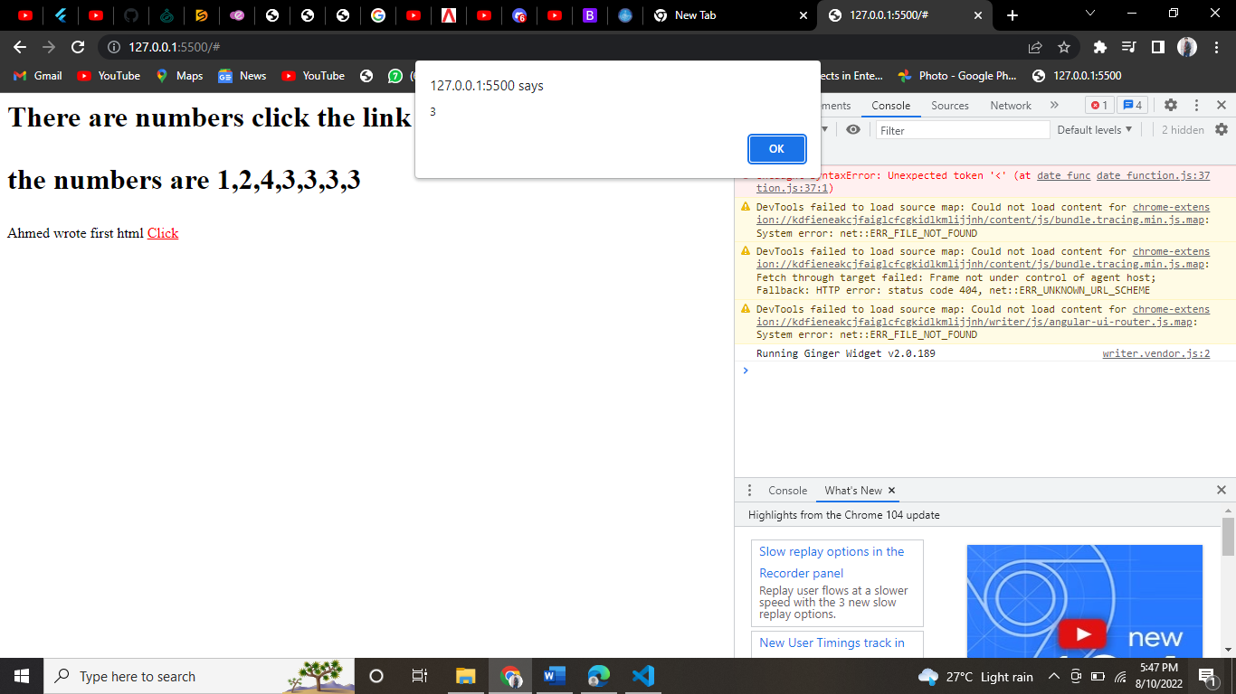

***Scripting Approach :***

There’s a separate file known as javascript file with .js extension is made and this file’s coding is used in html code for performing desired operations which is preferered by most of the professionals.

To do that dropout source of your separate .js file to html script body :

<script src="temp function.js"></script>

Now any function is present in there will be worked if called on as link or button etc

 </script><a href="#" onClick="sub(5,4);">Click</a><code></code>

Note:

Wrote above click script inside heading paragraph or div etc to make things appear.

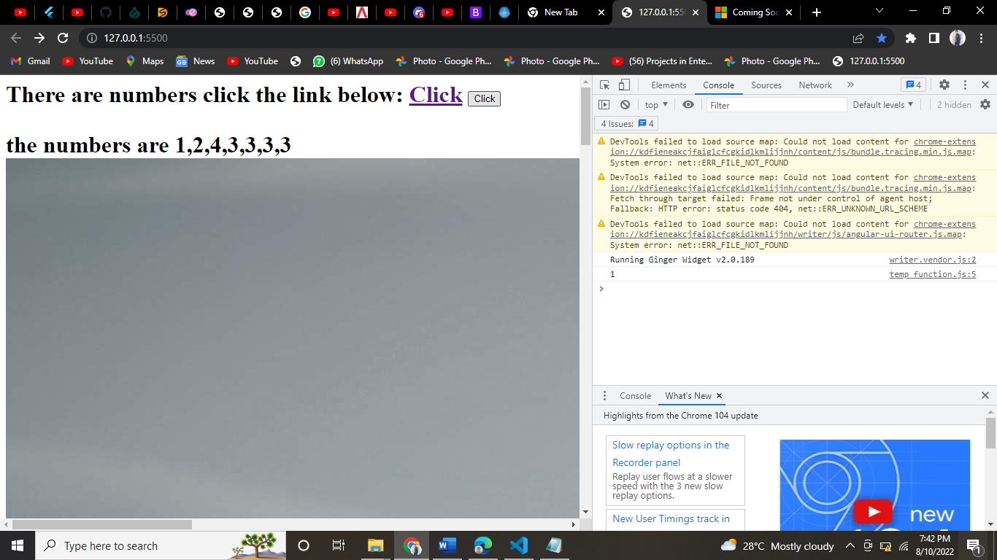



***Events button:***

Last time we have learning in line scripting in which a link is clicked and it reload the result save in that particular link’s script at html code underwhich javascript code is saved.

Here in scripting approach rather than a link we use buttons when we trigger a button by clicking on it ,it reloads the operation assigned to that button which is a javascript code basically.

The event handler is same as in link at event button method :

**onClick="alert('Hello world!');"**

**<input type="button" value="Click"**

And combining those two separations the Event button is made :

**onClick="alert('Button working!');"<input type="button" value="Click">**

***Events button image :***

We can place an image into html code on which when we click something event will happened as coded

For example :

            <input type="button" value="Click" onClick="sub(5,4)">

***Events Mouse over image :***

When you hover an image the image changes to after image as settled in javascript code.

Syntax:

It begins as a plain vanilla image tag: <img src="before-pic.jpg"

Then comes the event-handling keyword. The keyword is in camelCase—optional but

widely used: onMouseover

An equal sign follows the keyword onMouseover, just as it does with onClick. Then

comes the response to the event, which is in quotes: "src='after-pic.jpg'">

example :

<img src="image-blog-sql-database.jpg" onMouseover="src='1-LJeVeJKqiZ6vlsHKgRdrkw.png'">

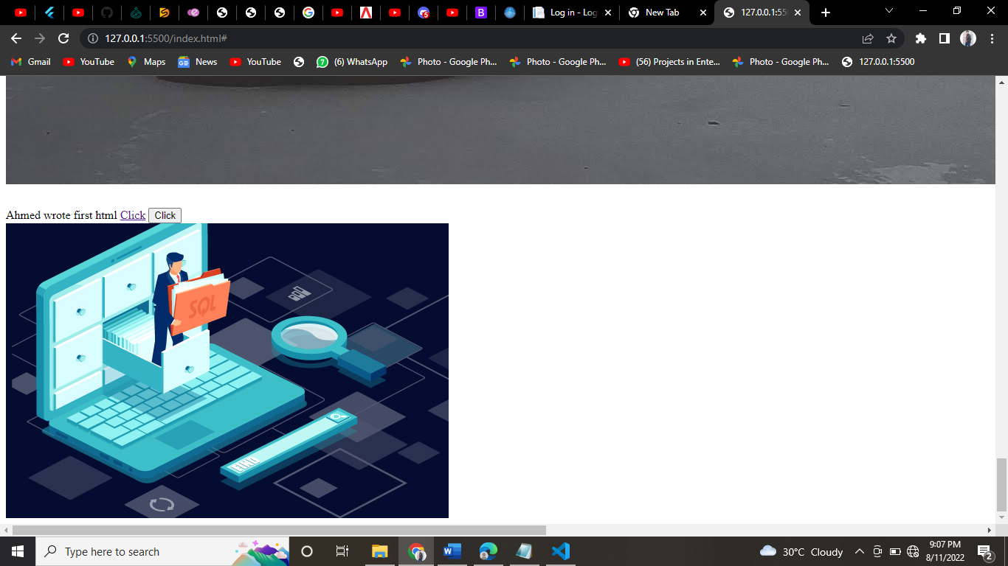 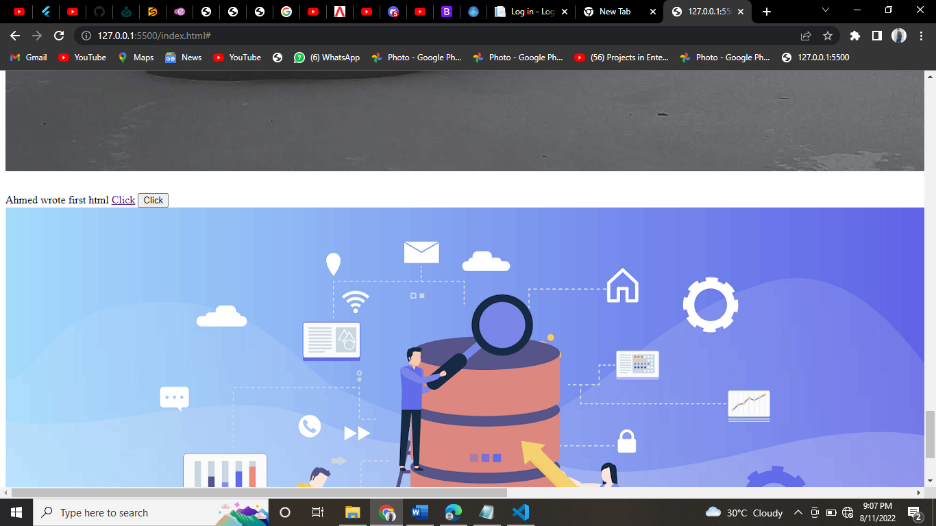

When the mouse over text a text display the message or anything you want to perform whenver mouse over a text:

                <h1 onMouseover="alert('Be sure to get your shopping done today.');">World Ends Tomorrow</h1>

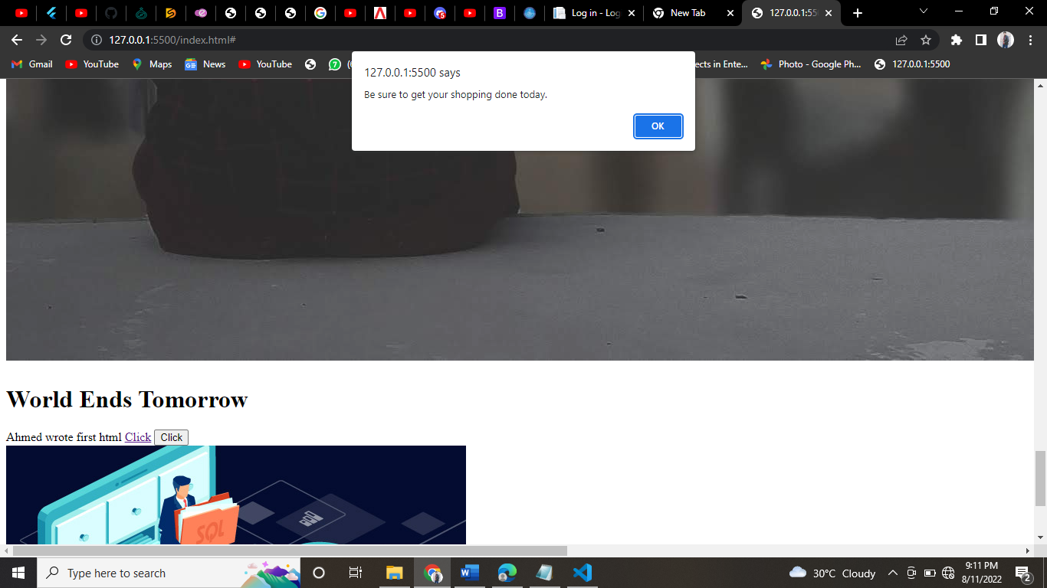

**Here's a JavaScript alternative to the preferred CSS color-change on hover.**

<a href="index.html" onMouseover="this.style.color='green';">Home Page</a>

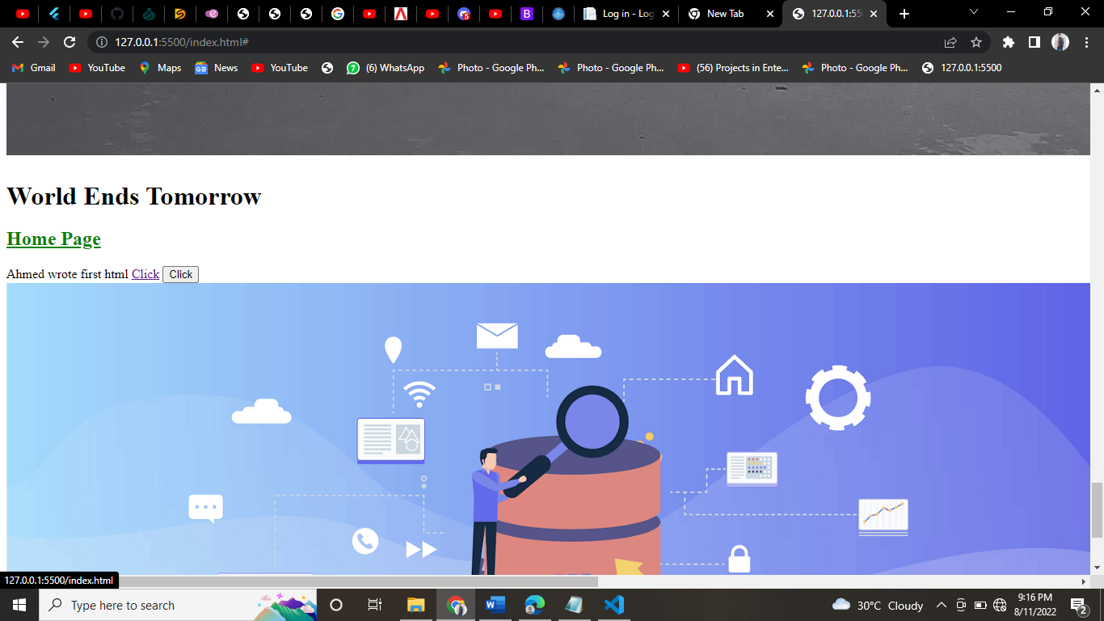

***you'd want the image to revert to the original when the user mouses away from the picture.***

            <img src="1-LJeVeJKqiZ6vlsHKgRdrkw.png" onMouseover="src='IMG_20191119_015008.jpg'" onmouseout="src='1-LJeVeJKqiZ6vlsHKgRdrkw.png'">

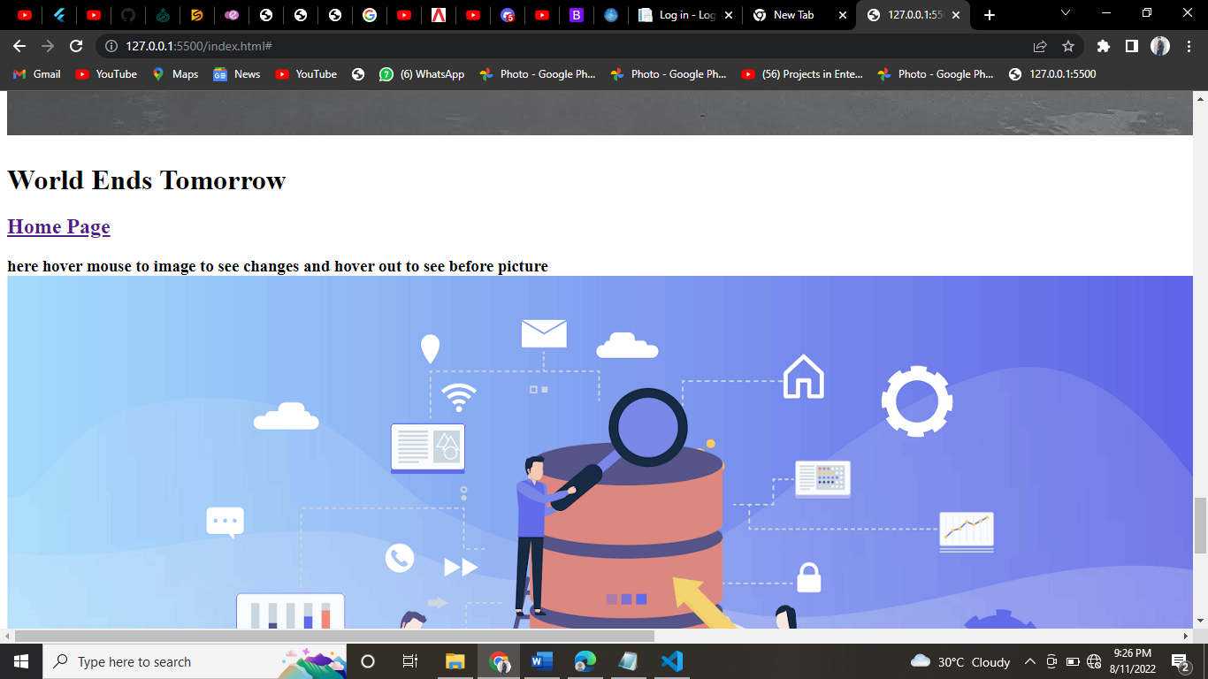 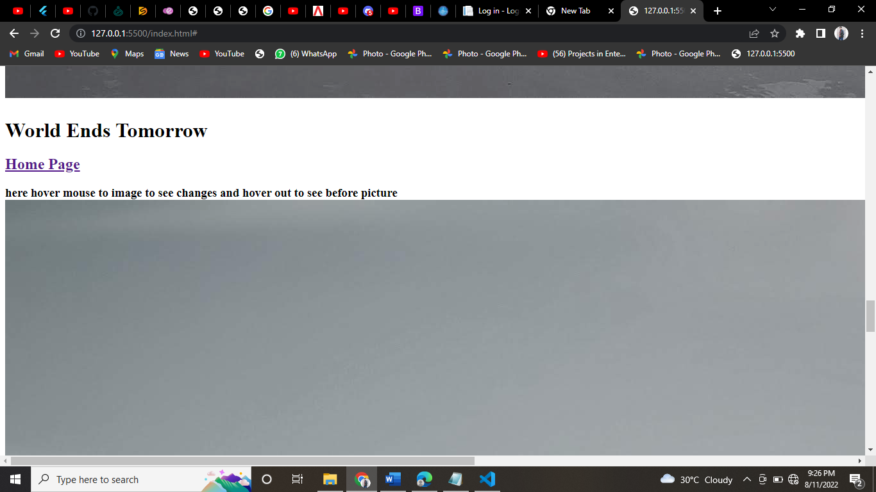

***text boxes for taking inputs***

normally you need a text field to perform your certain operations underthat

Email:<br>

<input type="text" size="30" onFocus="this.style.backgroundColor='yellow';">

***Reading fields in text boxes and displaying message using .js function calls:***

first we make text box as :

    <input type="text" id="email">

Then we called make the button to display message as whatever comes in the text field :

    <input type="submit" value="submit">

We placed the function in the form tag above all code I mentioned earlier :

    <form onsubmit="checkAddress('email')">

We maked the function for checking if text field is empty if text field have same value as we want then we display a message if text field isn’t empty we display form submit message then we called out function in the field as mentioned above :

  function checkAddress(fieldId) {

         if (document.getElementById(fieldId).value === "") {

         alert("Email address required.");

         }

         else(

           alert("form submitted !")

         )

         if(document.getElementById(fieldId).value === "Pakistan"){

            alert("your city is karachi !")

         }

         }

Combining all above except function it looks like this as a complete text field and button function code :

 <form onsubmit="checkAddress('email')">

        <input type="text" id="email">

        <input type="submit" value="submit">

          </form>

Setting field values :

When the user clicks a button something will display as per what he wrote in the text field earlier

    <form>

        ZIP:<br>

        <input type="text" id="zip" onBlur="checkout();"><br>

        City:<br>

        <input type="text" width="50" id="city">

        </form>

Function inside of above is below here :

    function checkout(){

            var city_name;

            var check=document.getElementById("zip").value;

            switch(check){

                case "8084" :

                    city_name="Karhwan bhai ka city karachi maaon !";

                    break;

                case "6078" :

                    city_name="aby jaldi likh tere city ka naam panvel h";

                    break;

                default :

                    city_name="invalid entry";

            }

            document.getElementById("city").value=city_name;

         }

***Key Triggered : (show message)***

<div id="wrapper">JavaScript is fun!</div>

 <input type="text" name="myNum1" onkeypress="numCheck()">

 <input type="text" name="myNum2" onkeypress="numCheck2()">

 <script>

 function numCheck() {

 message("Number: " + !isNaN(event.key));

 return !isNaN(event.key);

 }

 function numCheck2() {

 message("Not a number: " + isNaN(event.key));

 return isNaN(event.key);

 }

 function message(m) {

 document.getElementById('wrapper').innerHTML = m;

 }

 </script>

***Submitting a form which will redirect to another page:***

Page 01 form making :

<form action="anotherpage.html" method="get">

    <input type="text" placeholder="name" name="name" />

    <input type="submit" value="send" />

Page 02 : form accepting.

    <p id = "those">

    </p>

    <script>

        let q = window.location.search;

 let params = new URLSearchParams(q);

 let name = params.get("name");

 console.log(name);

 welcome("welcome here");

function welcome(m){

document.getElementById("those").innerHTML = m;

}

    </script>